# CITY OF SAN DIMAS

**NOTICE OF INTENT TO ADOPT A MITIGATED NEGATIVE**

**DECLARATION**

**APPLICATION – PROJECT** Zone Change 22-0001, Tentative Tract Map 22-0001

**DESCRIPTION**: General Plan Amendment 22-0001; Tree Removal Permit 22-0029; and Development Plan Review Board 21-0002

Consideration of a Zone Change, General Plan Amendment, Vesting Tentative Tract Map, Tree Removal Permit and Development Plan Review Board for the creation of seven single-family parcels from two existing parcels, with an associated Zone Change from SF-A16,000 to SF-7,500 and General Plan Amendment from Single-Family Very Low to Single-Family Low. The project site is currently developed with one single-family residence, which will be demolished. The project would complete of the existing cul-de-sac. In addition to the project site, an additional 17 parcels, which are already developed with single-family residences, will be rezoned from SF-A 16,000 to SF 7,500 and have their General Plan Designation changed from Single-Family Very Low to Single-Family Low.

**PROJECT LOCATION:** 327 E. Baseline Road

Northeast Corner of Baseline Road and Cherokee Court,

San Dimas, CA 91773

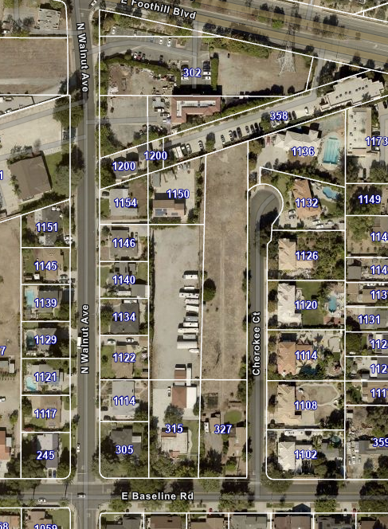

*Proposed Project site is highlighted in red, Areas proposed to be rezoned in yellow.*

The proposed project site is located at 327 East Baseline Road (APN’s 8661-017-010 and -011) in the City of San Dimas and is developed with one single-family residence. The project site is surrounded by commercial use to the north and single-family residences to the east, west and south. Local access to the Project Site is provided by Baseline Road and Cherokee Court, with regional access provided by the Interstate 210/Foothills Freeway, approximately 600 feet to the south.

The Zone Change and General Plan Amendment proposed will also affect 17 parcels adjacent to the project site on the East and West, as well as properties on the West side of N. Walnut Avenue, North of E. Baseline Road (APNs 8661-014-005 through -011, 8661-017-008, -009, -021 through -027).

**ENVIRONMENTAL: The City of San Dimas hereby gives notice that pursuant to the authority and criteria contained in the California Environmental Quality Act (CEQA) and the CEQA Guidelines, Staff has analyzed the request for the following:**

After reviewing the Initial Study and any applicable mitigating measures for the project, Staff has determined that this project will not have a significant effect on the environment. Accordingly, a Mitigated Negative Declaration has been prepared.

**Public comments on the Mitigated Negative Declaration will be received by the City beginning on March February 1, 2024, through 5:00 PM on February 21, 2024.** Architectural review for the proposed project will be considered by the Development Plan Review Board (DPRB) at a later date. Additionally, the proposed project and the associated Mitigated Negative Declaration are anticipated to be heard by the San Dimas Planning Commission and the San Dimas City Council at a later date. Any future public meetings/hearings by either the DPRB, San Dimas Planning Commission or the San Dimas City Council will be noticed as required.

**PROJECT APPLICANT:** Stan Stringfellow, Development One Group

**STAFF CONTACT:** Ken Fichtelman, Associate Planner

[KFichtelman@Sandimasca.gov](mailto:KFichtelman@Sandimasca.gov) (909) 394-6256

Copies of all relevant material, including the project specifications and all documents referenced in the Mitigated Negative Declaration, are available for public inspection at San Dimas City Hall, Planning Division, 245 East Bonita Avenue, San Dimas and the City of San Dimas website <https://sandimasca.gov/departments/community_development/planning_division/development_projects_environmental_info.php>. Electronic format of the document(s) can also be obtained by contacting Ken Fichtelman at 909.394.6256. City Hall is open Monday through Thursday, 7:30 a.m. to 5:30 p.m., and on Fridays from 7:30 a.m. to 4:30 p.m. The project site is not listed on any list of hazardous waste sites prepared pursuant to Government Code Section 65962.5.

The City is requesting your participation in this public review process. Please submit written comments relating to the Mitigated Negative Declaration. Correspondence should be addressed to the City of San Dimas, Community Development Department, 245 East Bonita Avenue, San Dimas, CA 91773. All comments must be received by no later than 5:00 p.m. on February 21, 2024.